Scalars and Vectors
- Scalars are quantities which only have size (magnitude), such as distance, speed, mass and energy.
- Vectors are quantities with size and direction, such as displacement, velocity, acceleration, force and weight.
- Resultant force is a vector quantity
- Forces acting in the same direction can be added together
- Forces acting in opposite directions can be subtracted
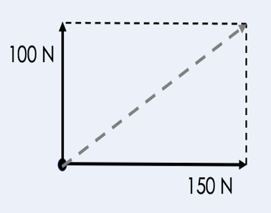
- Resultant forces can be resolved into their horizontal and vertical components
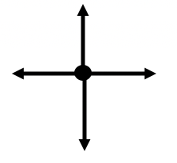
Newton’s Laws
- Newton’s Third Law states that every action has an equal and opposite reaction
- Newton’s First Law states than an object’s motion will not change unless acted upon by an unbalanced force
- If the resultant force is 0 N a stationary object will remain stationary
- If the resultant force is 0 N an object in motion will continue moving at the same velocity
- If the resultant force is not 0 N a stationary object will accelerate in the direction of the resultant force
- If the resultant force is not 0 N an object in motion will accelerate in the direction of the resultant force

Acceleration
- Acceleration is the rate of change of velocity
- Change in velocity is calculated using final velocity minus initial velocity
- Acceleration happens when there is change in velocity (speeding up, slowing down or a change in direction)
- Negative acceleration (slowing down) can be called deceleration
- The SI unit for acceleration is m/s²
- An object moving in a circle is accelerating because it is constantly changing direction
- Objects near Earth’s surface experience gravitational acceleration of 9.8 m/s²
- Air resistance/drag increases with speed
$$Acceleration= \frac{Change in velocity}{Time}$$

Velocity-Time Graphs
- Velocity-time graphs can be used to describe motion
- A horizontal line shows a constant velocity
- A straight line with a positive gradient (slope) shows that an object has a positive acceleration (speeding up)
- A straight line with a negative gradient (slope) shows that an object has a negative acceleration/deceleration (slowing down)
- Acceleration can be calculated by calculating the gradient
- Distance can be calculated from the area under the graph
- A curved line shows that acceleration is changing

